http://165.22.217.185/layout/submaster/chemistContactPerson
Shows “City” instead of Chemist Name.
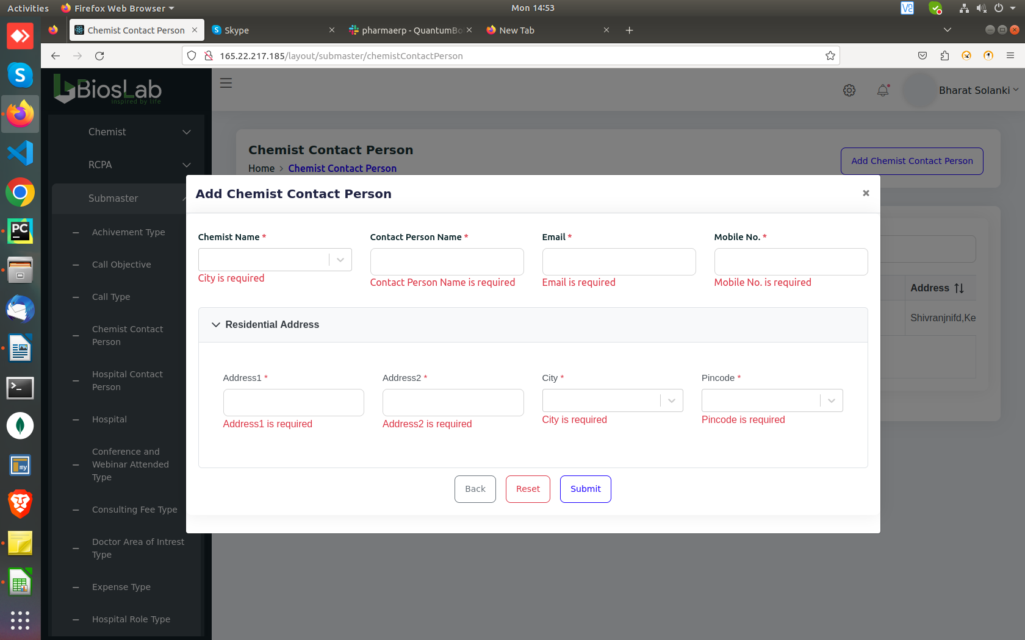

http://165.22.217.185/layout/submaster/hospitalContactPerson
Shows “City” instead of “Hospital Name” in error message.
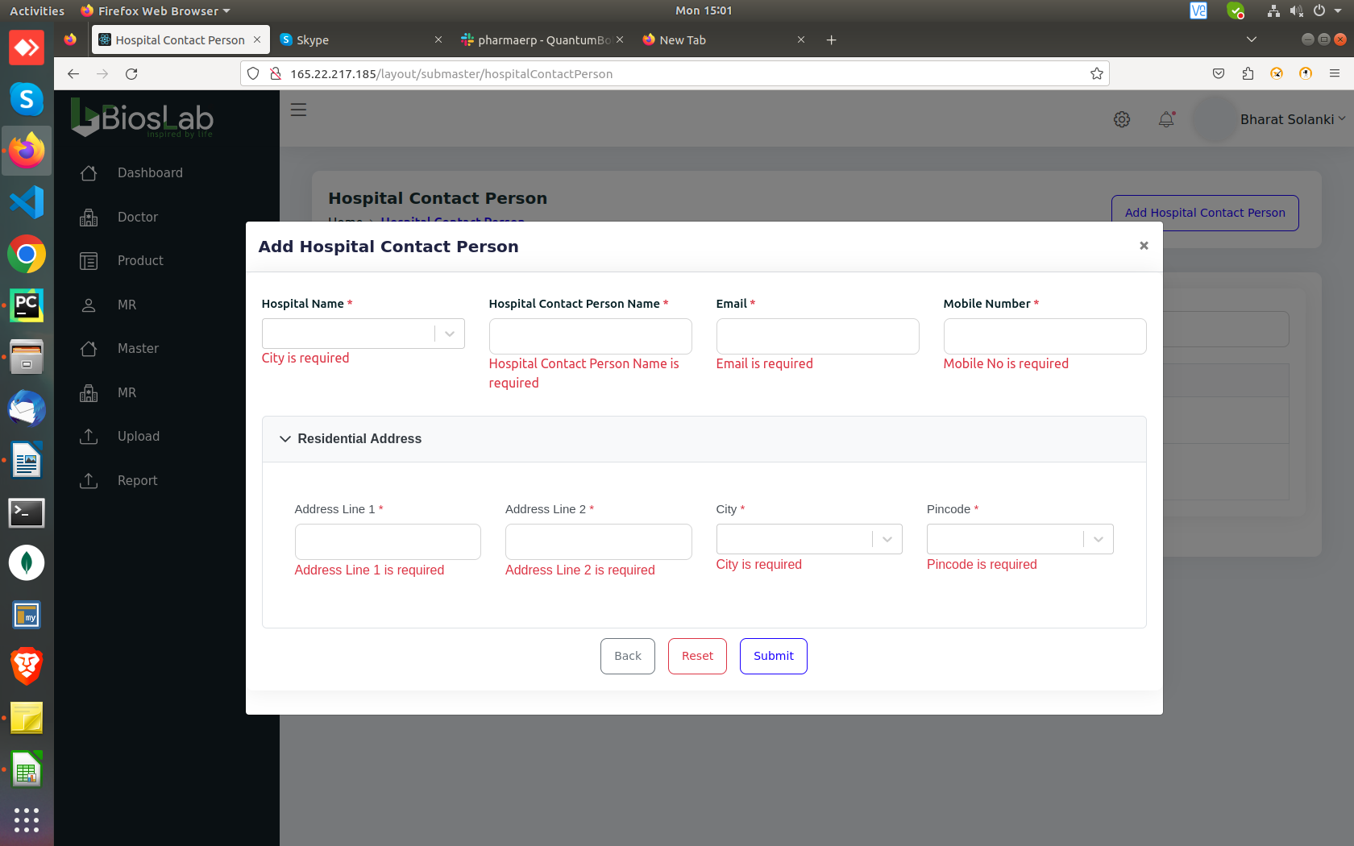

http://165.22.217.185/layout/submaster/hospital
Shows “Chemist...” instead of “Hospital Name”
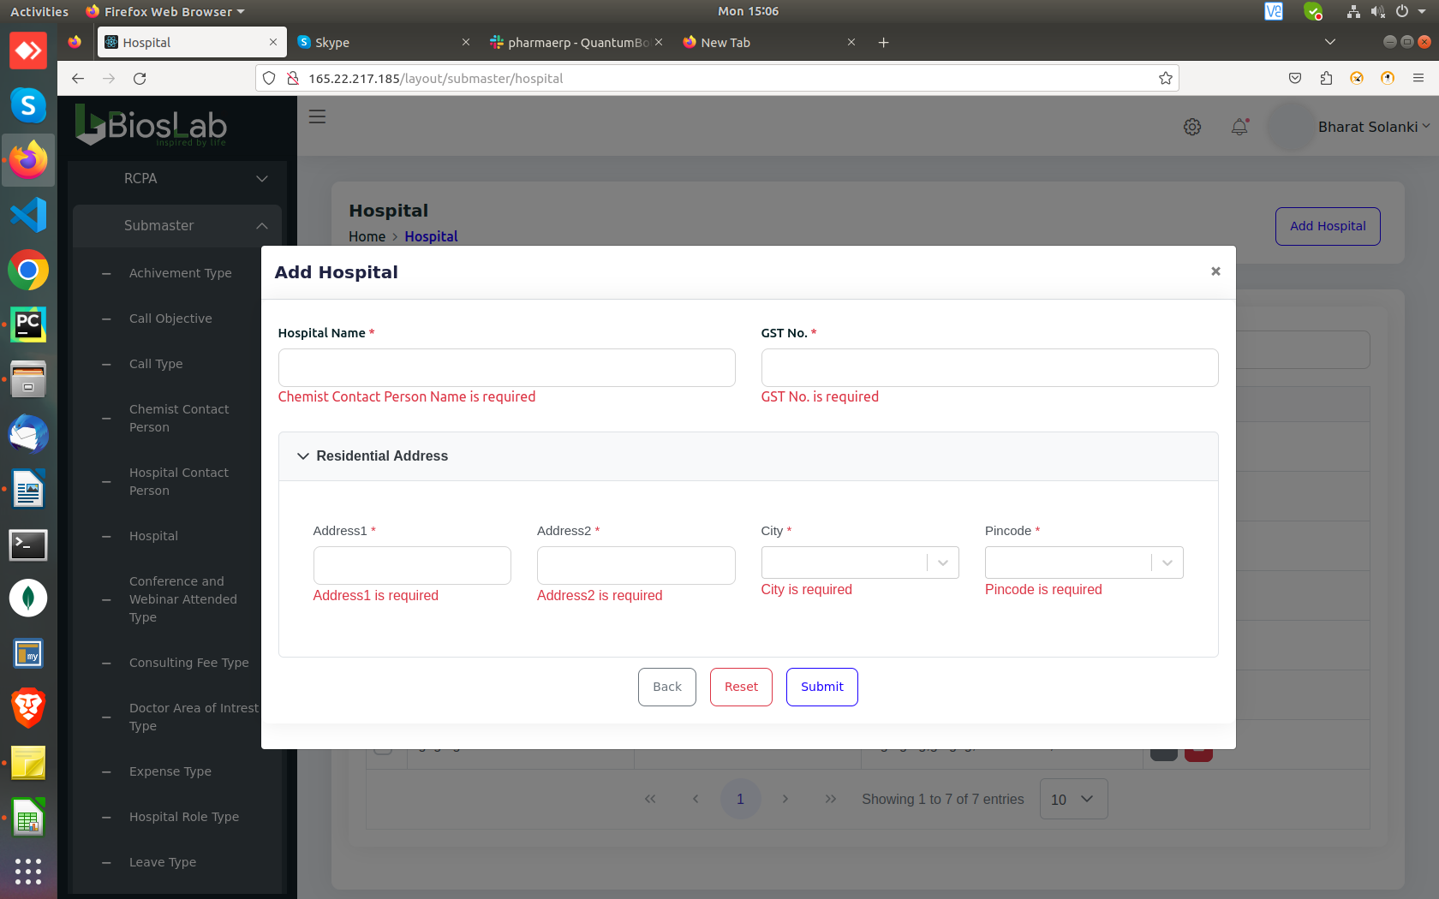

http://165.22.217.185/layout/submaster/consultingFeeType
improper error message
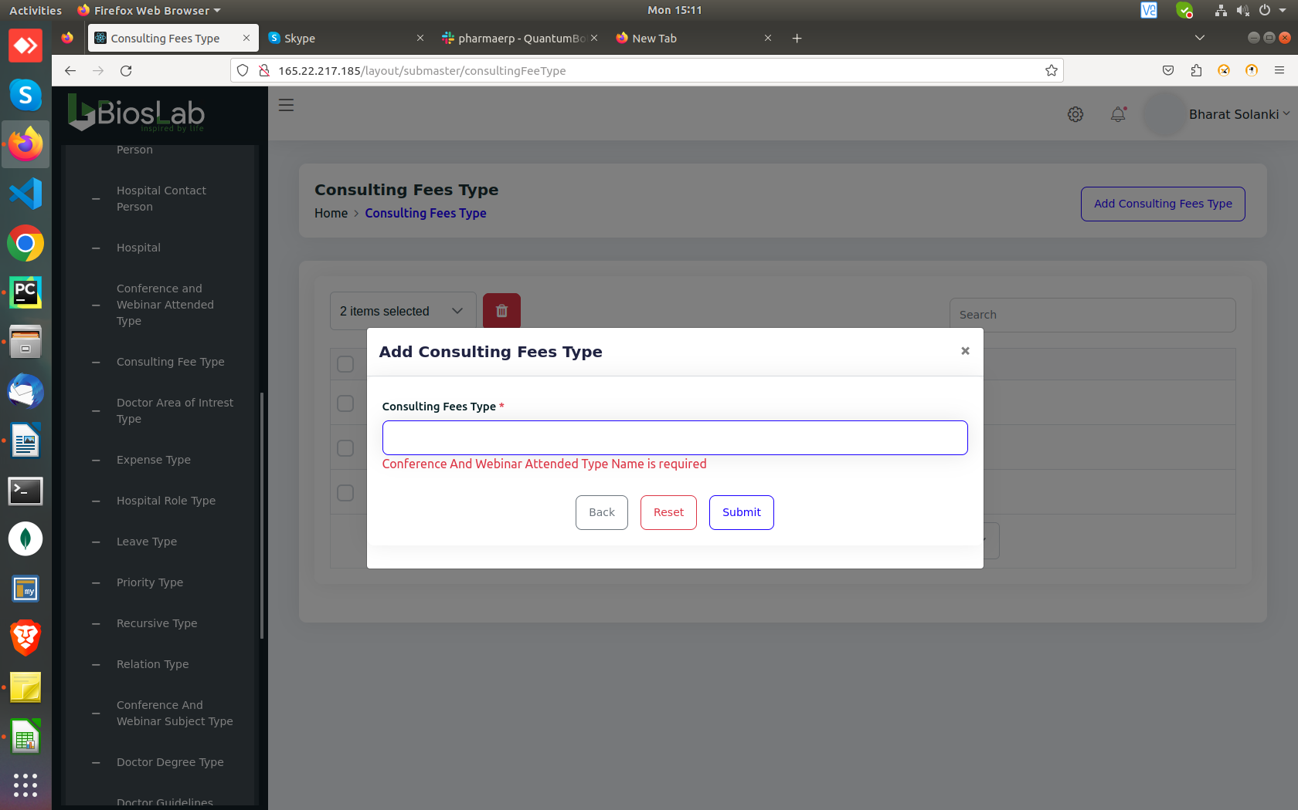

http://165.22.217.185/layout/submaster/expenseType
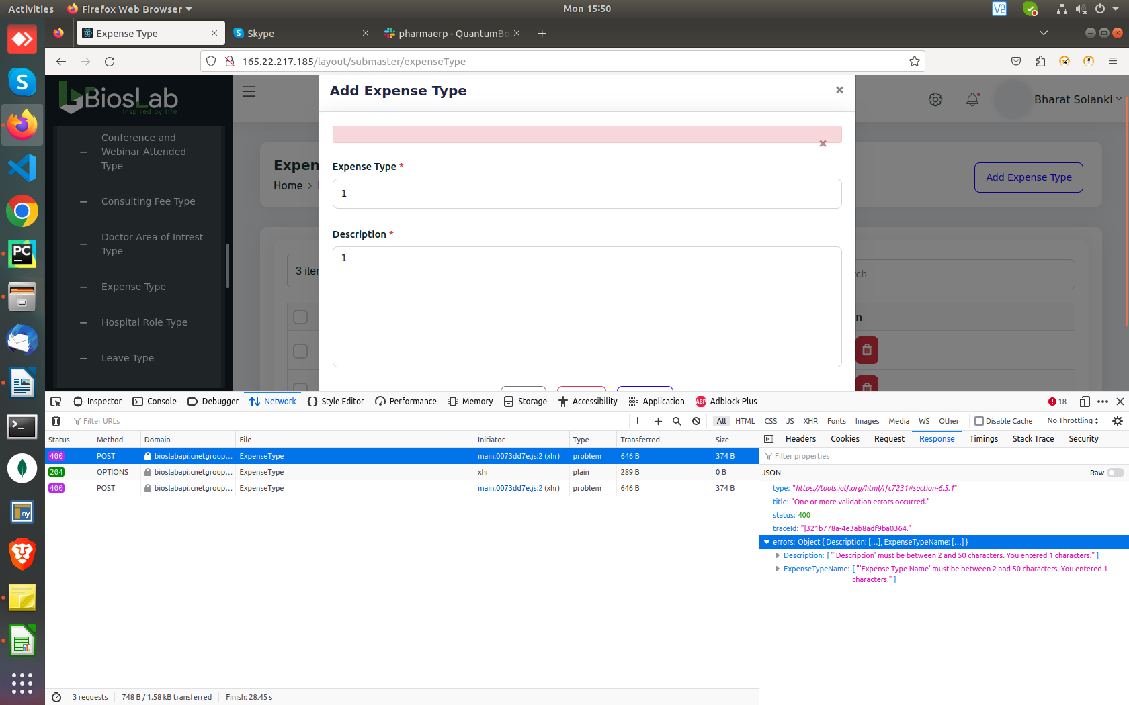

http://165.22.217.185/layout/submaster/leaveType
improper error message
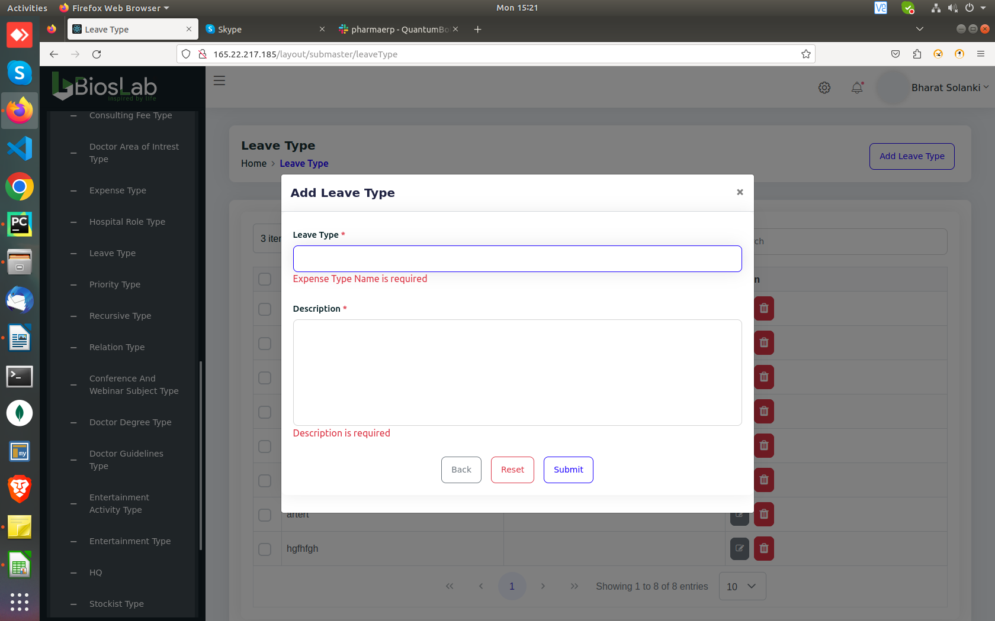

http://165.22.217.185/layout/submaster/priorityType
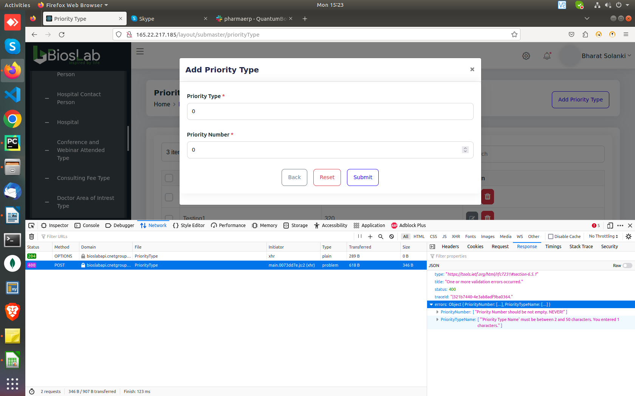

http://165.22.217.185/layout/submaster/recursiveType
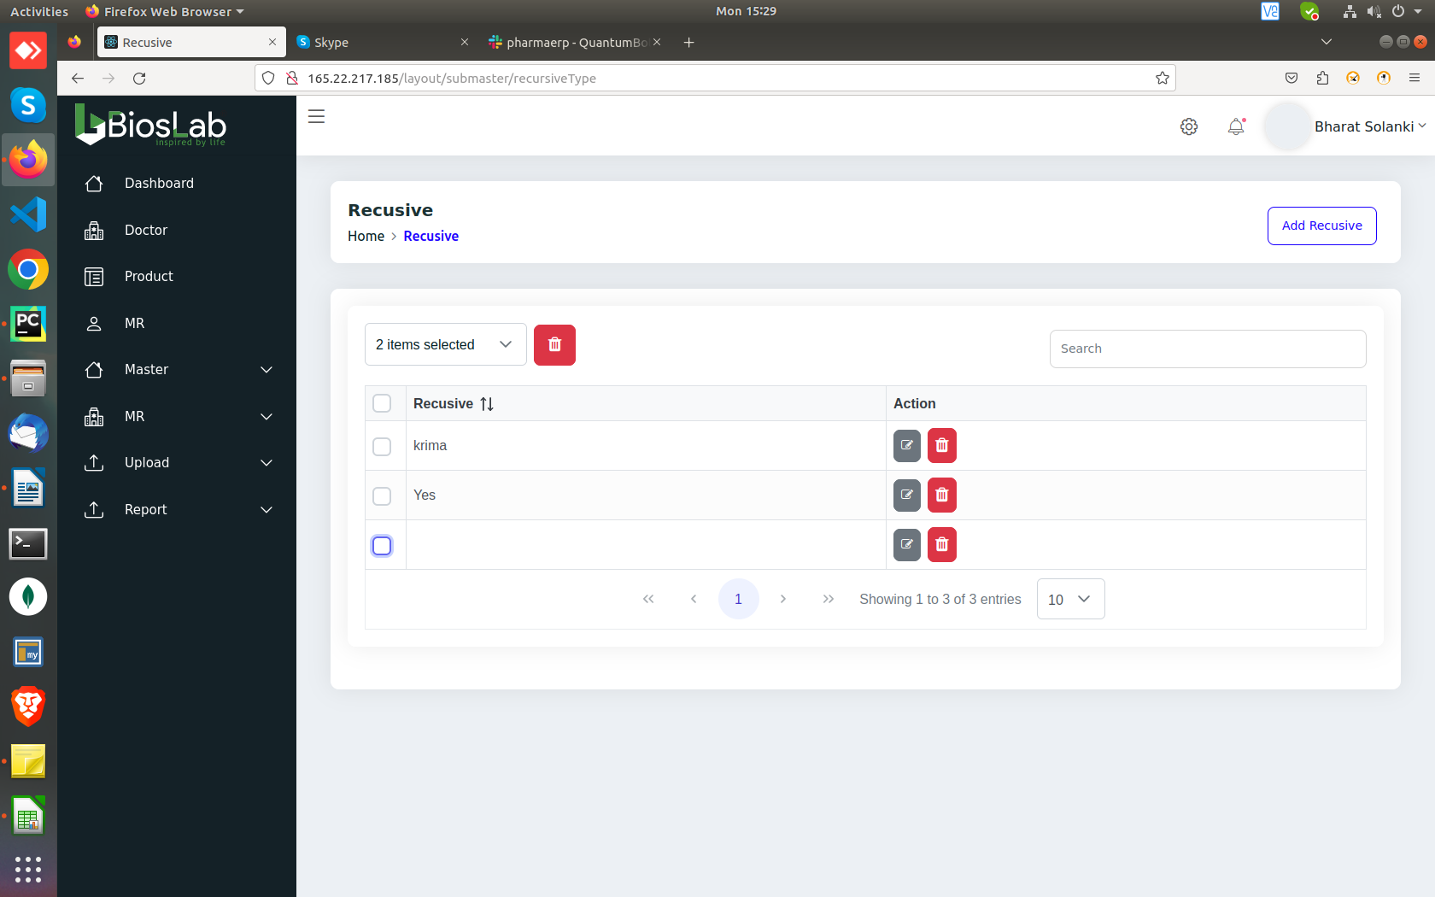
“Blank(By giving spaces)” recursive gets created

http://165.22.217.185/layout/submaster/doctorDegreeType
improper error message
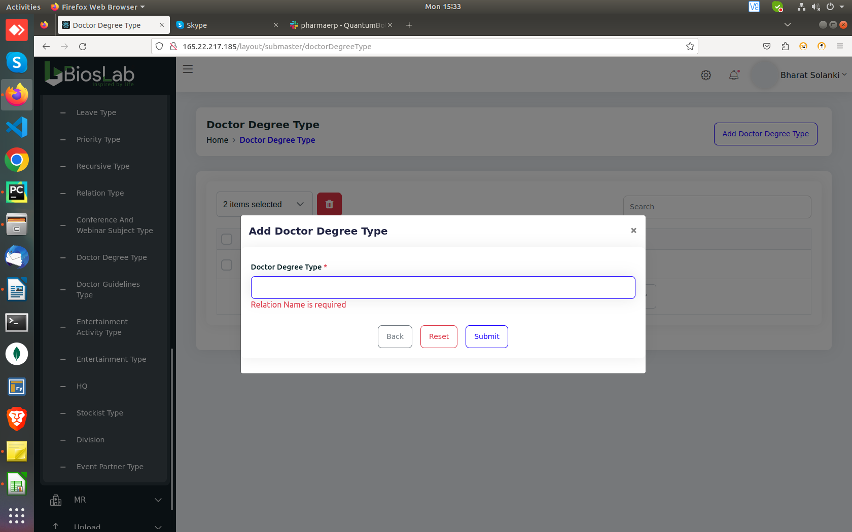

http://165.22.217.185/layout/submaster/entertainmentType
After creating and deleting a field, upon trying to enter the same data again, it Shows “data already exists”. In “Entertainment Activity type” as well as in “Entertainment type”. i.e. Try creating “Movies”.
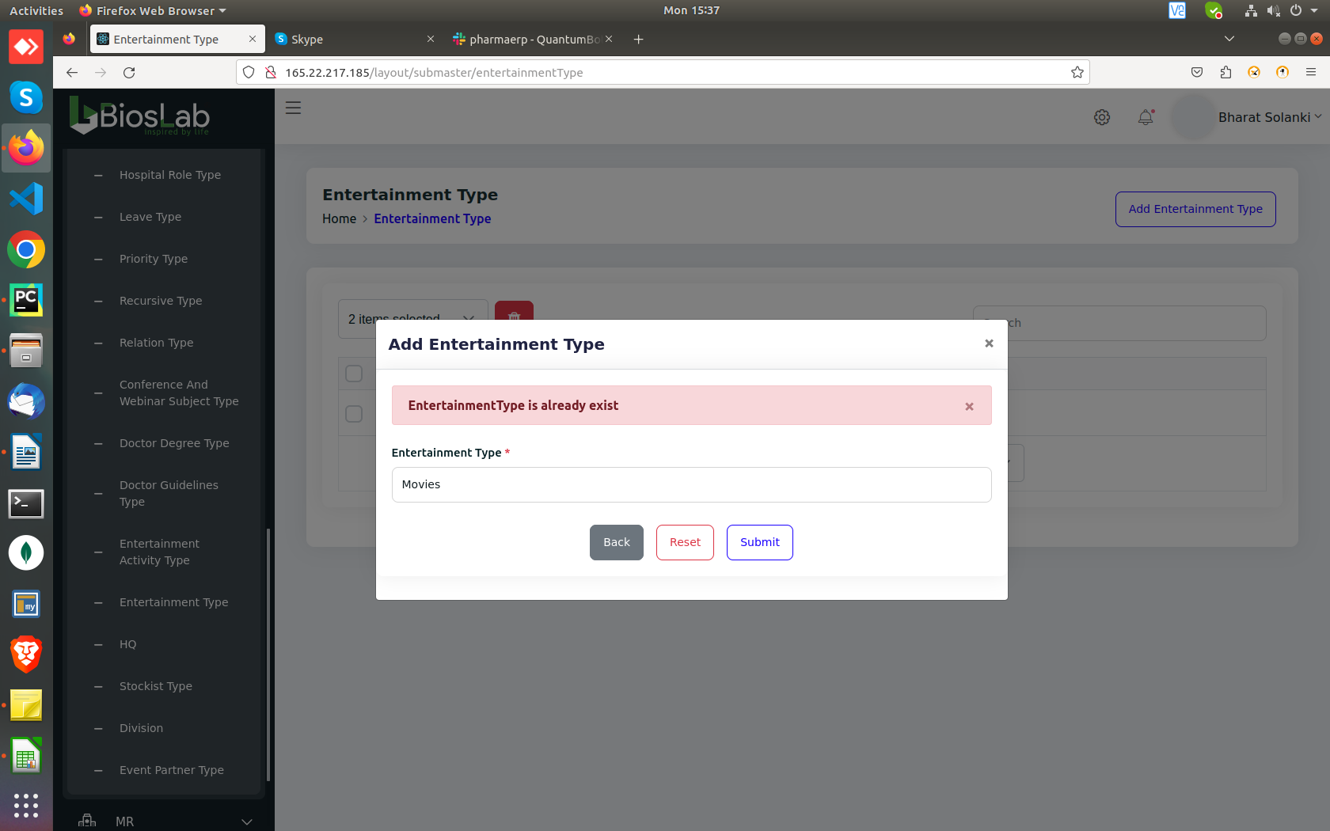

Common Issues:
- Enter Button doesn’t work.
- Reset button won’t reset the dropdown values.
- Email and Phone number validation is missing.
- After clicking “Edit” button, “Action” gets unselected from the dropdown but still shows quick action buttons.
- Giving spaces as a value throws red banner without any information in it with following log

errors | Object { Description: […] }
Description | [ "... should be not empty. NEVER!"

Spellings of recursive in http://165.22.217.185/layout/submaster/recursiveType

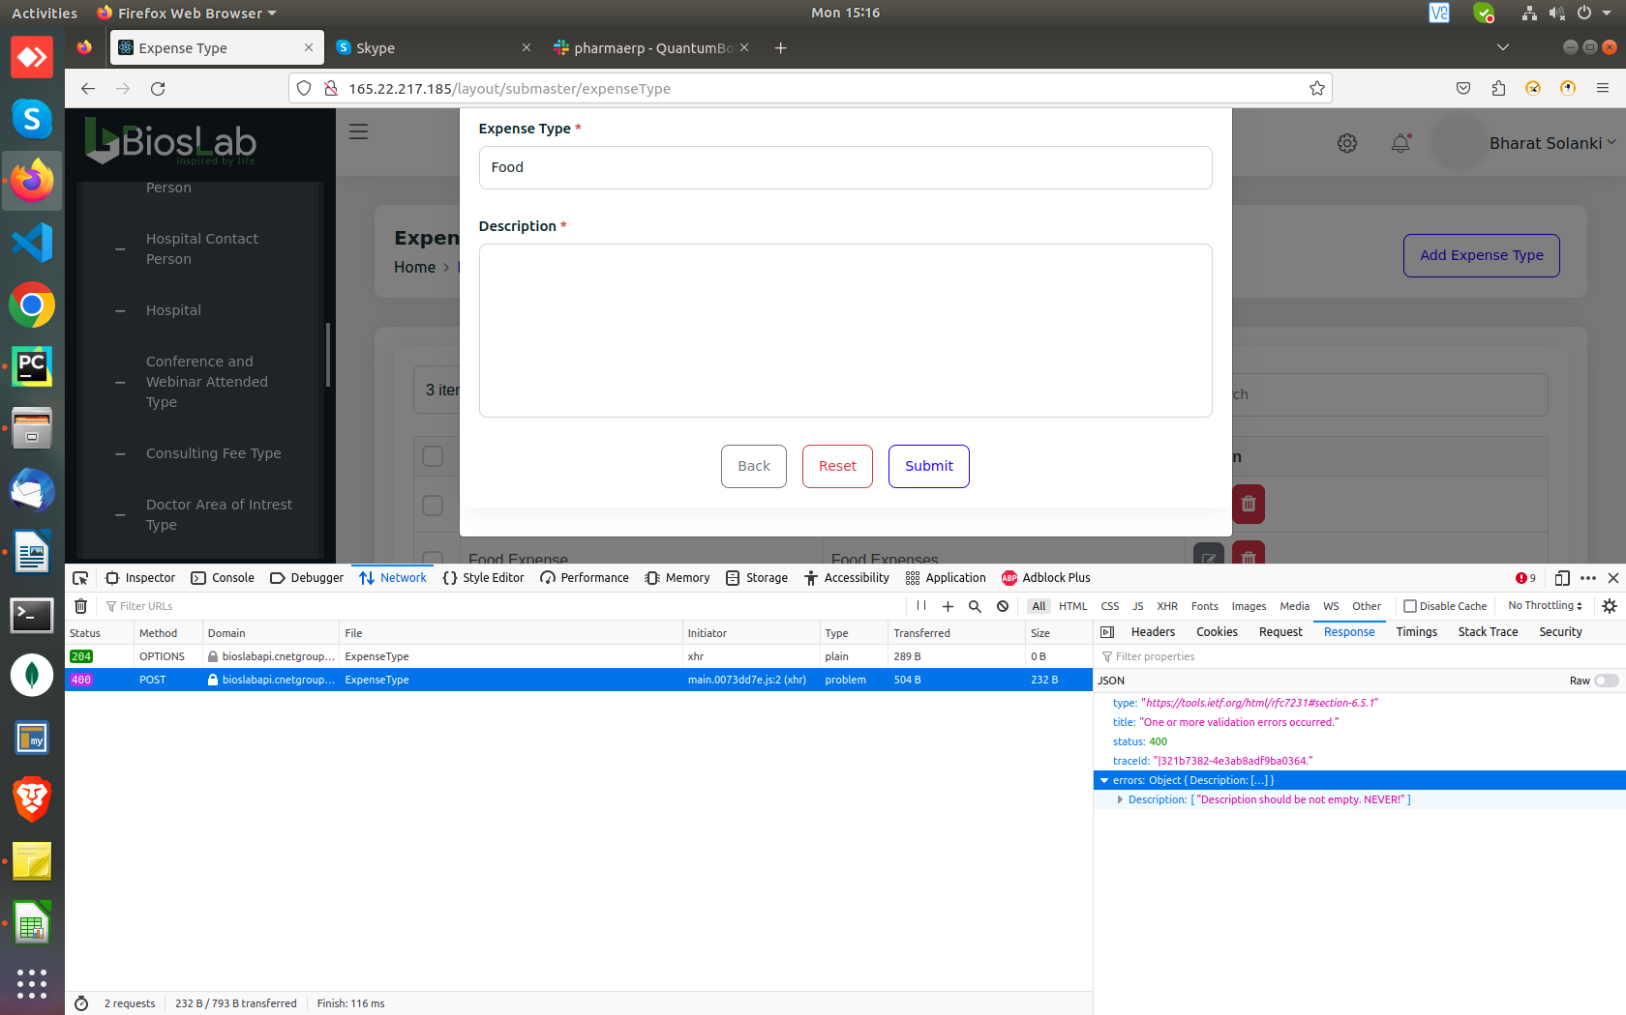

Multiple data with same values can be created in Call Objective, Call type, Chemist Contact Person, Hospital Contact Person, Conference, Consulting Fee Type, Doctor area of Interest,Hospital Role, Priority Type, Recursive, Realtion, HQ, Stockist type.

